**DAILY ONLINE ACTIVITIES SUMMARY**

|  |  |  |  |  |  |  |  |  |
| --- | --- | --- | --- | --- | --- | --- | --- | --- |
| **Date:** | **09/06/2020** | | | | | **Name:** | **POOJA D S** | |
| **Sem & Sec** | **4th SEM 'B' Section** | | | | | **USN:** | **4AL18CS056** | |
| **Online Test Summary** | | | | | | | | |
| **Subject** | | **......** | | | | | | |
| **Max. Marks** | | **30** | | **Score** | | | **......** | |
| **Certification Course Summary** | | | | | | | | |
| **Course** | **Introduction to Cyber Security** | | | | | | | |
| **Certificate Provider** | | | **Great Learning Academy** | | **Duration** | | | **5.5 hour** |
| **Coding Challenges** | | | | | | | | |
| **Problem Statement:** A user will input two strings, and we find if one of the strings is a sub sequence of the other. Program prints “yes” if either the first string is a sub sequence of the second string or the second string is a sub sequence of the first string. Assume that, the length of the first string is smaller than or equal to the length of the second string. Assume that, the length of the first string is smaller than or equal to the length of the second string. | | | | | | | | |
| **Status: completed** | | | | | | | | |
| **Uploaded the report in Github** | | | | | **yes** | | | |
| **If yes Repository name** | | | | | <https://github.com/dspooja/Java-coding>  <https://github.com/dspooja/C-coding> | | | |
| **Uploaded the report in slack** | | | | | **yes** | | | |

Online Test Details: (Attach the snapshot and briefly write the report for the same)

Certification Course Details: (Attach the snapshot and briefly write the report for the same)

Coding Challenges Details: (Attach the snapshot and briefly write the report for the same)

CERTIFICATION COURSE DETAILS:

* As continuation of the Introduction to Cyber security online course**.**
* **The concepts covered in** Introduction to Cyber security **are:**
* Introduction to Cryptography
* Secure System Design

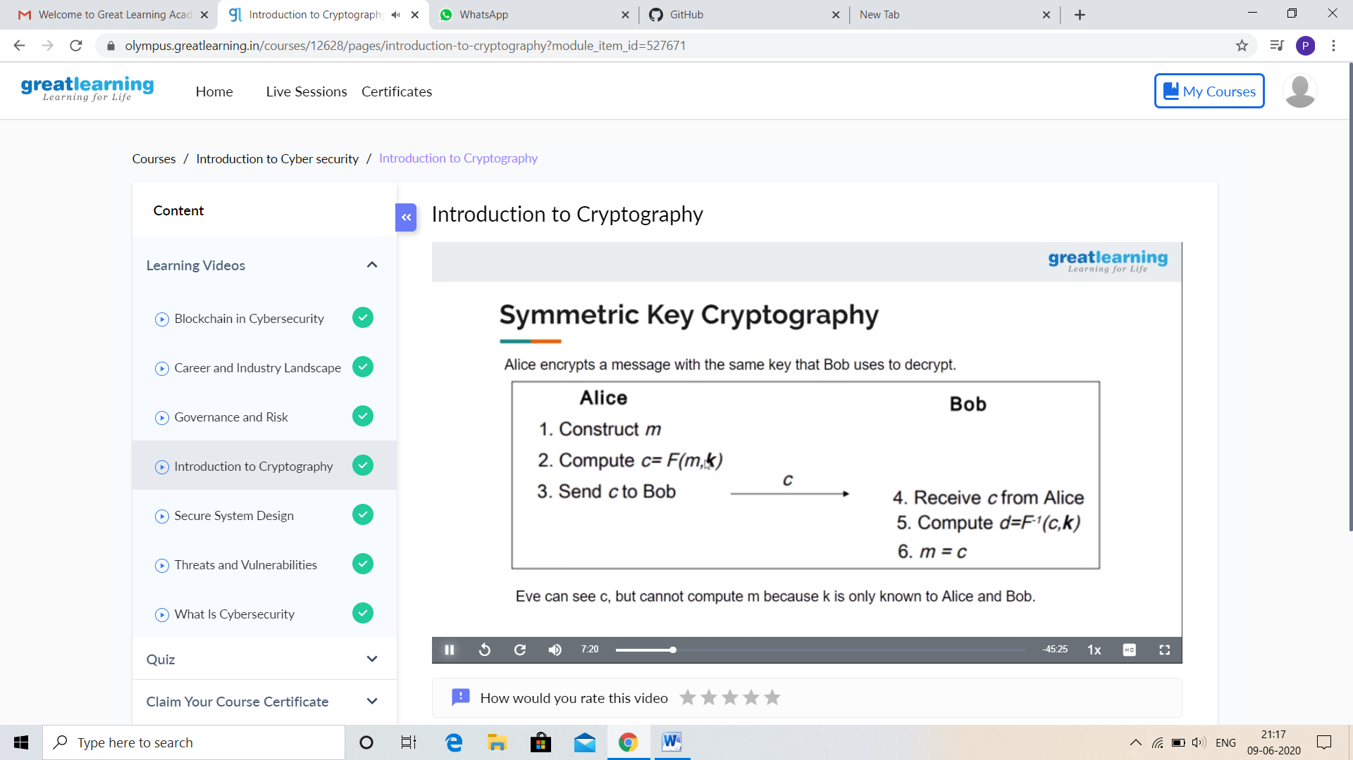

And I Participate in the Webinar “Brain Computer Interface” on 5th June.

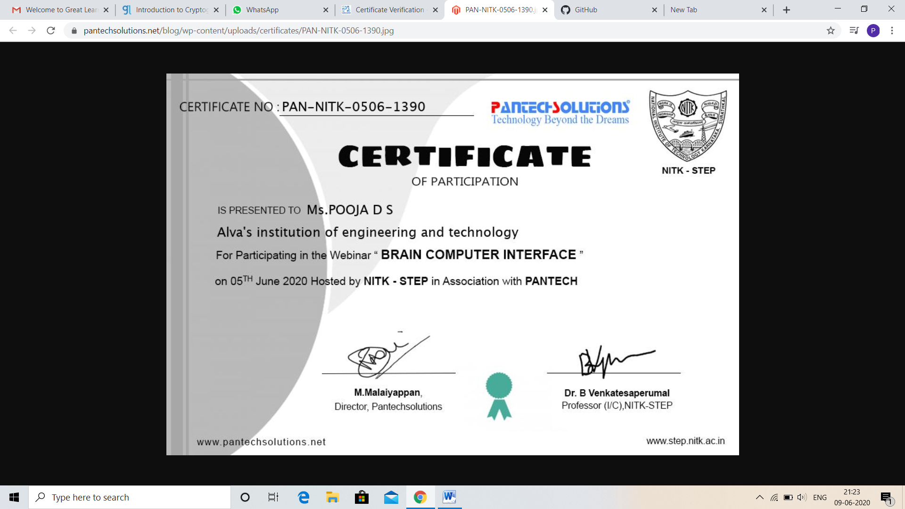

CODING CHALLENGES DETAILS:

Problem statement 1:

Write a java program to count all the triplets such that sum of two elements equals the third element.

Given an array of distinct integers. The task is to count all the triplets such that sum of two elements equals the third element.

Input:  
The first line of input contains an integer T denoting the number of test cases. Then T test cases follow. Each test case consists of two lines. First line of each test case contains an Integer N denoting size of array and the second line contains N space separated elements.

Output:  
For each test case, print the count of all triplets, in new line. If no such triplets can form, print "-1".

Constraints:  
1 <= T <= 100  
3 <= N <= 105  
1 <= A[i] <= 106

**Example:**  
Input:  
4  
1 5 3 2

Output:  
2

Explanation:  
There are 2 triplets: 1 + 2 = 3 and 3 +2 = 5

Solution: Uploaded it in github

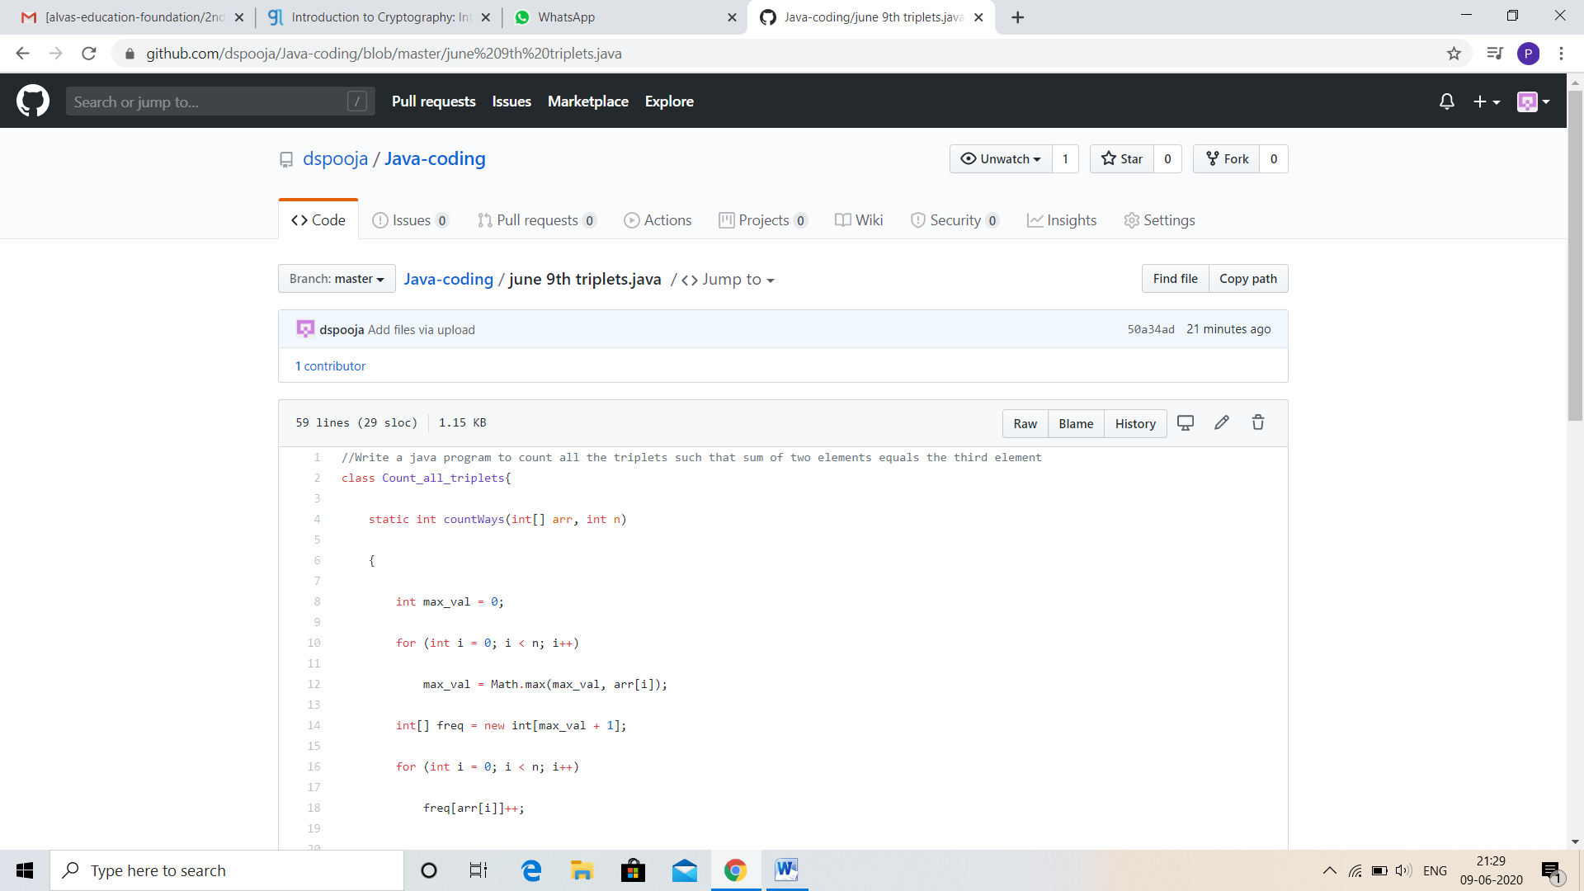

Problem statement 2:

Write a Java Program to find total number of subarrays which start and end with the same element.

Given an array A of size N where the array elements contain values from 1 to N with duplicates, the task is to find total number of subarrays which start and end with the same element.  
**Examples:**

Input: A[] = {1, 2, 1, 5, 2}  
Output: 7  
Explanation:  
Total 7 sub-array of the given array are {1}, {2}, {1}, {5}, {2}, {1, 2, 1} and {2, 1, 5, 2} are start and end with same element.

Solution: Uploaded in github.

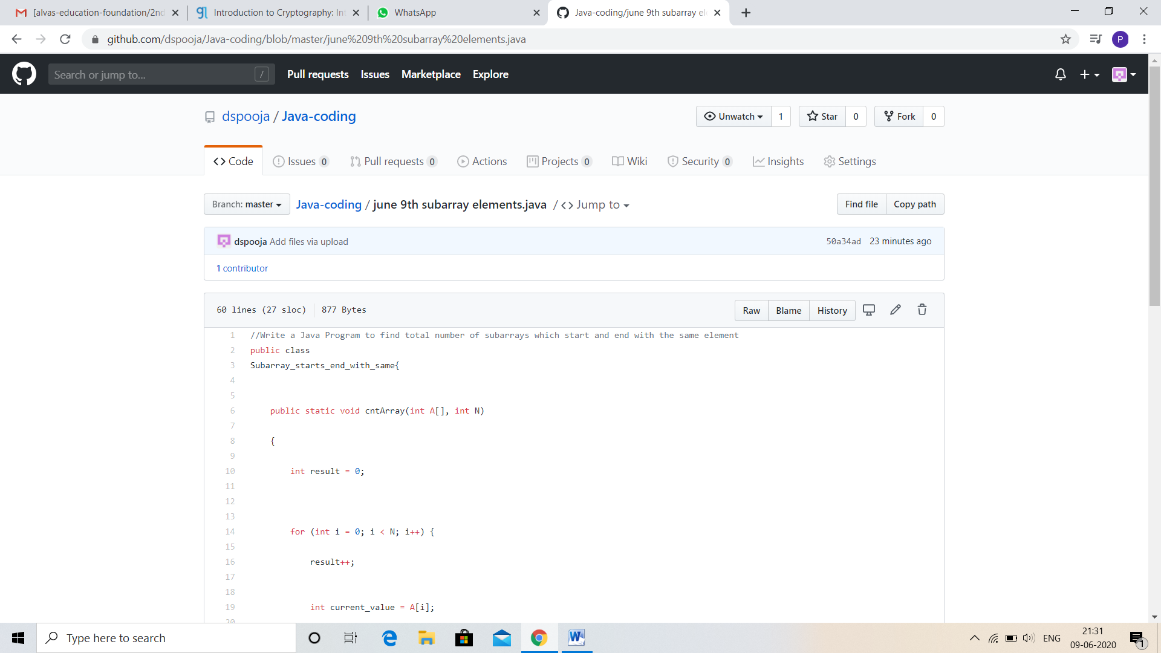

Problem statement 3:

Write a C Program to rotate the matrix by K times Program in C

Rotate the matrix by K times means rotating the given NN matrix to the specified (K) number of times. For example, consider the 33 matrix, which has to be rotated once,  
Enter the Size of the Matrix: 3, 3  
Enter the Elements of the Matrix: 10, 20, 39, 40, 50, 60, 70, 80, 90  
Enter the value of K (Number of Rotations): 1  
Matrix before Rotation:  
10 20 30  
40 50 60  
70 80 90  
Matrix after Rotation:  
20 30 10  
50 60 40  
80 90 70

Solution: Uploaded in github.

